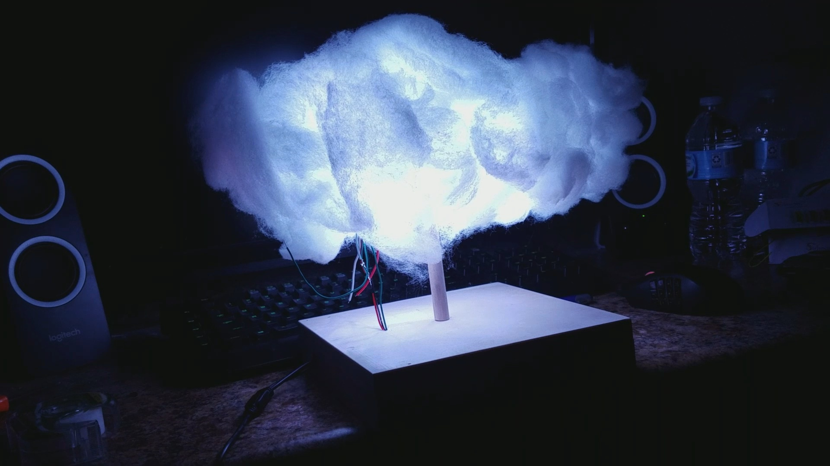

RASPBERRY PI WEATHER CLOUD

***Raspberry Pi Weather Cloud Instruction Set***

Andrew Riebow

Published on Saturday, March 16th, 2019.

Table of Contents

Key terms 4

Table of illustrations 5

Preface 6

General Purpose 6

Scope 6

Background 7

Project Description 7

Materials NeedeD 8

Description of Equipment or Operations 9

SQLite 9

Apache Web Server 9

PuTTY 9

Assembly, Setup, Installation 10

1d) Setting up File Transfer 16

2)Installing Software 17

2a) Installing Apache and Php 17

Implementation of SQLite 24

Standard Operating Procedure 27

Troubleshooting 28

Dowel 30

6316U 30

Key terms

* Raspberry Pi Zero W
* Weather Cloud
* PSU (power supply unit)
* LED
* WSR281x Power strip
* PuTTY

Table of illustrations

|  |  |
| --- | --- |
| Figure 1a. | Page 11 |
| Figure 1b. | Page 12 |
| Figure 1c. | Page 13 |
| Figure 2a. | Page 14 |
| Figure 2b. | Page 15 |
| Figure 2c. | Page 16 |
| Figure 2d | Page 16 |
| Figure 2e | Page 18 |
| Figure 3a | Page 21 |
| Figure 3b. | Page 21 |
| Figure 3c. | Page 19 |
| Figure 4a. | Page 25 |
| Figure 4b | Page 25 |

Preface

# General Purpose

The purpose of these instructions is to give detailed steps on creating a Raspberry Pi Weather Cloud. The weather cloud will contain LED lights powered by a raspberry pi. The lights will change colors based on the weather forecast. A more specific description will be given in the next section. These instructions will cover assembling all of the parts to create the finished product, as well as setup and installation of any required software.

# Scope

This instructional set will only cover one specific way to setup and assemble the weather cloud. This is a project that could be modified in many ways to fit your needs. There are a variety of methods to setup this project, and alternative software could be used in many cases. To avoid overcomplication, very specific software and assembly steps will be used.

Background

# Project Description

The Raspberry Pi Weather Cloud displays the weather forecast by changing the colors of an LED strip. It also acts as a controllable LED light. A Raspberry Pi is used to control the LED lights, host a website on your local network, and store weather data in its database. The Raspberry Pi is placed inside a 8x8x2 wooden box, which acts as the base for the whole weather cloud. The LED strip is placed inside a clear 1-liter bottle, which is mounted sideways above the box. The bottle is covered with Polyfiber filling, which makes it resemble a cloud. The Raspberry Pi will connect to your local network, and you will be able to access a website it is hosting in order to change the color of the lights.

Materials NeedeD

* + - * Raspberry Pi Zero W with headers
      * Polyfiber filling
      * Hot Glue
      * 5v 5a PSU
      * Jumper Wires (Male to Male and Female to Male)
      * Level Converter
      * Breadboard
      * Dowel
      * Wooden box 8x8x2 (LxWxH) that can open and close
      * Empty Liter soda bottle
      * WS2812 LED strip
      * DC Female power plug to 2 pin terminal adapter
      * DC barrel jack splitter
      * USB SD card reader (optional)

Description of Equipment or Operations

# SQLite

SQLite is one of the most popular database engines in the world. It is a c-language library that implements a SQL database engine. The main function is to implement a shared repository of data. It provides local data storage for individual applications and devices, so it was perfect for our specific use case. The database stores the weather data that changes the color of the cloud.

# Apache Web Server

Apache Web server provides a secure and efficient server that is up to date with current HTTP Standards. We used the Apache Web Server to hose the website from our PI machine. The website allows the user to remotely control the lights. It also allows us to run server-side code to access the database information as we needed.

# PuTTY

PuTTY is a free network file transfer application. For our purposes we use SSH to connect to the Raspberry PI device.

Assembly, Setup, Installation

1) Setting up the Raspberry Pi

1a) Setting up the SD Card

First, you will need to download the operating system, Raspbian, onto your SD card. These instructions will show you how to use NOOBS, an easy installer for Raspbian

1. Put your SD card into your SD card slot on your computer OR put it into a USB SD Card reader
2. Go to the Raspberry Pi Foundation download page (<https://www.raspberrypi.org/downloads/>)
3. Click on the NOOBs icon, and download it as a ZIP file.
4. Download a SD card formatter (<https://www.sdcard.org/downloads/formatter_4/index.html>)
5. Run the card formatter, select the correct drive, select “Quick Format”, and click Format (WARNING: This will erase any data currently on your SD card!)

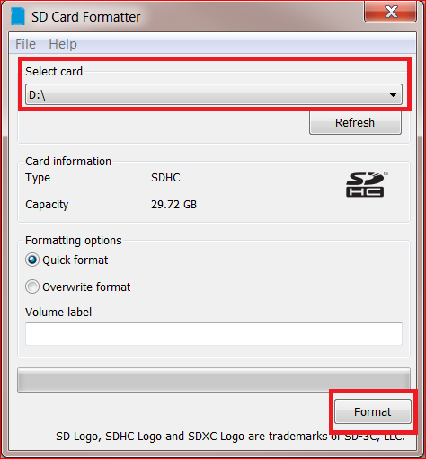Figure 1a.

1. Extract the data from the ZIP file onto the SD card
2. Add an empty .txt file on the SD card, and name it “wpa_supplicant”
3. Open it up, and add the following lines

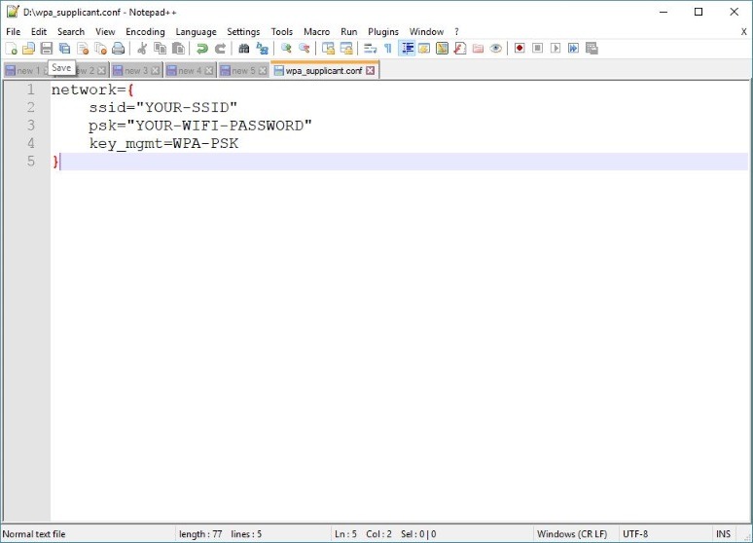Figure 1b.

For “YOUR-SSID”, add the name of your network at home (Keep the quotes)

For “YOUR-WIFI-PASSWORD", enter your password for your wifi (If you do not have a password, leave this blank)

This will allow the Raspberry Pi to automatically connect to your local network when it powers on

1. Add another empty .txt fille named “ssh”. Do not add any text inside of this file. This will allow the Raspberry Pi to be remoted into using secure socket shell.
2. Download the python script file from <https://github.com/andrewrgit/WeatherCloud>. It is named “weatherScript.py”. This is the main script that will run 24/7 to allow the weather cloud to function.
3. Move the script onto the SD card
4. Eject the SD card

1b) Powering on the Raspberry Pi

Now that the SD card has been properly formatted, and all the necessary files have been created, it is time to start up the Raspberry Pi.

1. Insert the SD card into the Micro SD card slot on the Raspberry Pi

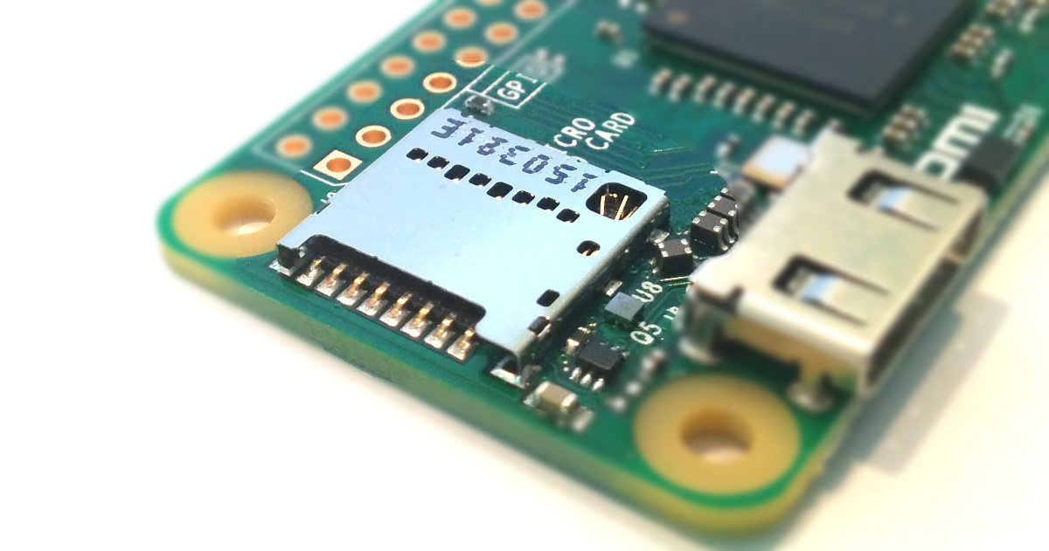Figure 1c.

1. Plug in your power supply to the wall, and then plug it into the Raspberry Pi. The Green LED on the Raspberry Pi should begin flashing.

1c) Remoting into the Raspberry Pi

Now we need to access the Raspberry Pi’s command line. The Pi has a built-in desktop display, which would show up if we connected a monitor to it. However, that will not be necessary for these instructions.

1. Download PuTTY (<https://www.putty.org/>)
2. Download Fing from the Google Play Store/Apple Store on your phone. Fing will be used to find the IP address that the Pi has been assigned on your network.
3. Start Fing. Look for the IP address with the host machine name of “Pi”. This is the default name for a Raspberry Pi. The screen should look like this: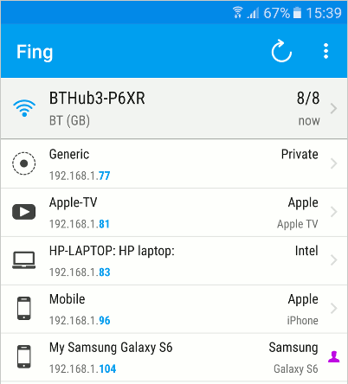Figure 2a.
4. Start PuTTY. Under Host Name, input the IP address of the Raspberry Pi. The PuTTY application should look like this: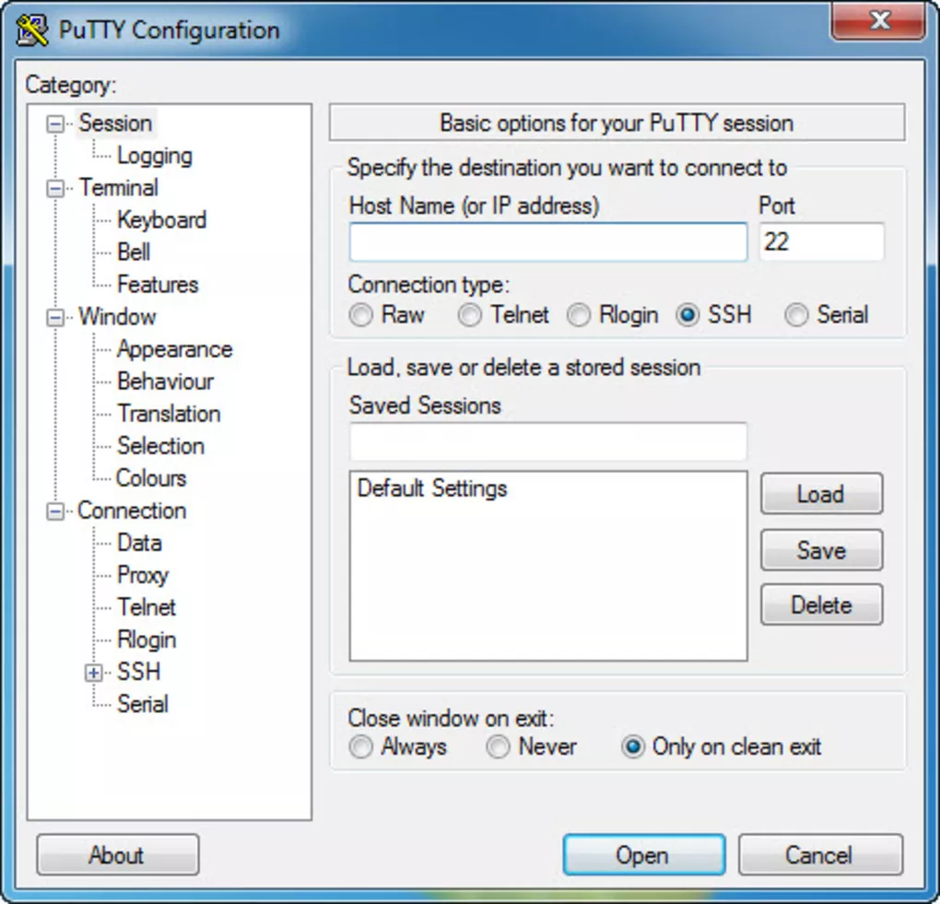Figure 2b.
5. Click Open. A command line terminal should be opened up, and it will ask for credentials. The default username is “Pi” and the default password is “password”. Normally, it would be a good idea to change these for security reasons. But since we are only opening up the Raspberry Pi to a local area network, there is no need. Input both and press enter

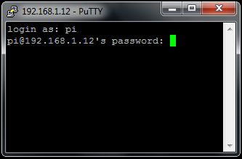Figure 2c.

You are now remotely accessing the Raspberry Pi. You will need to wait a few minutes for the operating system to finish installing.

# 1d) Setting up File Transfer

Next we will install a program called WinSCP. This will allow for the transfer of files to the raspberry pi remotely.

1. Download WinSCP from their website <https://winscp.net/eng/index.php>
2. Open WinSCP and enter the same IP address you used to remote into it with PuTTY. It will also ask for the same user credentials.

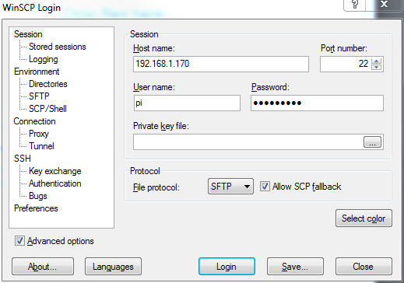Figure 2d

1. Click login. Afterwards, you should be shown a file structure of the Pi on the right, with the file system of your computer on the left. We will use this in the next section when we are installing the Apache web server.

# 2)Installing Software

# 2a) Installing Apache and Php

1. First we will install the Apache Web Server
   1. <https://www.raspberrypi.org/documentation/remote-access/web-server/apache.md>
2. It is important to update the available packages to ensure you have the latest version
   1. To update enter **“sudo apt-get update”** into the Terminal
3. Next install the apache2 package
   1. Enter **“sudo apt-get install apache2 -y”** into the Terminal
4. We will also need to install PHP
   1. Enter **“sudo apt-get install php libapache2-mod-php -y”** into the Terminal
5. Refresh WinSCP (Or re-login if you closed it)
6. Download the html folder from <https://github.com/andrewrgit/WeatherCloud/>
7. Drag the html folder you just download and replace the html folder on the Raspberry Pi. This folder has the website and all the buttons to control the lights.

Now, if you type in the Raspbery Pi’s IP address into your web browser on either your computer (or phone if it is connected to your wifi) you will see the weather cloud’s control panel.

2b) Installing SQLite

Now we will be installing SQLite. This is the database used to store all of the weather data. It is important to name the database, tables, and columns exactly correct.

1. Enter **“sudo apt-get install sqlite3”** into the command line. The Pi may ask for confirmation, in which case you will need to type **Y** and press enter.
2. Enter “**sqlite3 led.db”** into the command line. This will create a new database named “led”. You will now be able to use built-in SQLite commands to modify this database.
3. Enter **“CREATE TABLE mode(status TEXT, brightness integer, weatherTime text, alarmHour integer, alarmMinute integer, alarmMode text)”** This command creates a new table within that database. This will hold important information so the script knows what it should be doing.
4. Enter **“CREATE TABLE weather (Date text, DateAccessed text, weather1 integer, rain1 real, snow1 real, temp1 real, weather2 integer, rain2 real, snow2 real, temp2 real, weather3 integer, rain3 real, snow3 real, temp3 real, weather4 integer, rain4 real, snow4 real, temp4 real)”** This table will hold all of the weather information for different times of the day. It is important that these are all typed correctly.
5. Enter **“exit”** to leave the database edit mode.

3) Wiring the Raspberry Pi Weather Cloud

It is important that the Raspberry Pi is off for this part. To safely shutdown the Raspberry Pi, enter **“sudo shutdown –h now”** into the command line.

1. Take out the breadboard and LED strip and place it near the Raspberry Pi to begin wiring. The LED strip will have a JST connector on the end to facilitate easy wiring.
2. Use the following diagram as a reference for the GPIO pins on the Raspberry Pi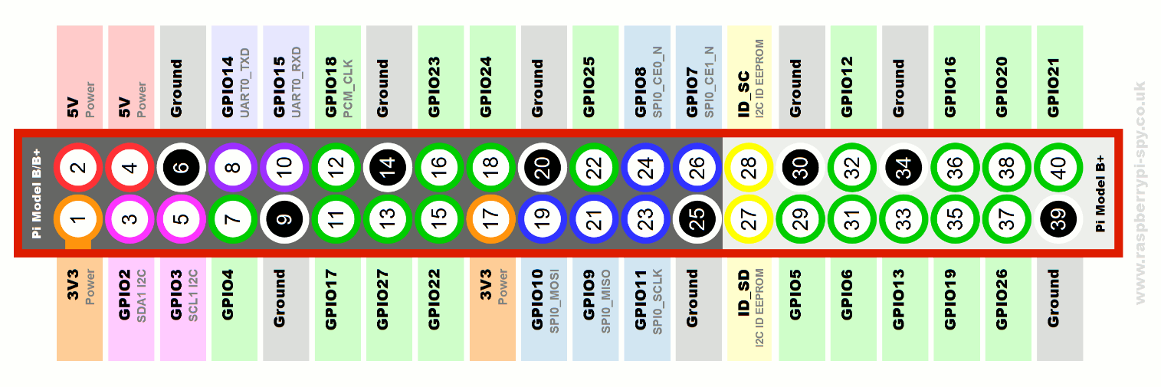

Figure 2e

1. Use a DC jack splitter to split the power supply line into two separate outputs.
2. Attach the Female DC power plug to 2 pin adapter onto the end of one of the outputs from the PSU
3. Put the level converter in the middle of the breadboard.
4. Wire from the negative and positive terminals on the 2 pin adapter to the negative and positive rails on the breadboard respectively.
5. Wire from the GRND and PWR sources on the LED strip to the same negative and positive rails on the breadboard respectively.
6. Use a Female to Male wire from GPIO18 on the Pi to 1A on the level converter.
7. Use a Male to Male wire from 1Y on the level converter to the DIN slot on the LED strip.
8. Wire from the ground rail to the level converter ground.
9. Wire from the ground rail to the 1OE pin on the level converter.
10. Wire from the ground rail to one of the grounds on the Raspberry Pi.
11. Wire from the positive rail to the VCC pin on the level converter.

Note the “Wiring Diagram” section for another view of how the wiring should look.

4) Creating the Stand

Now with the Raspberry Pi wired up and all the software installed correctly, it is time to put everything together. You will create a stand like the one pictured below to house the lights and Raspberry Pi.

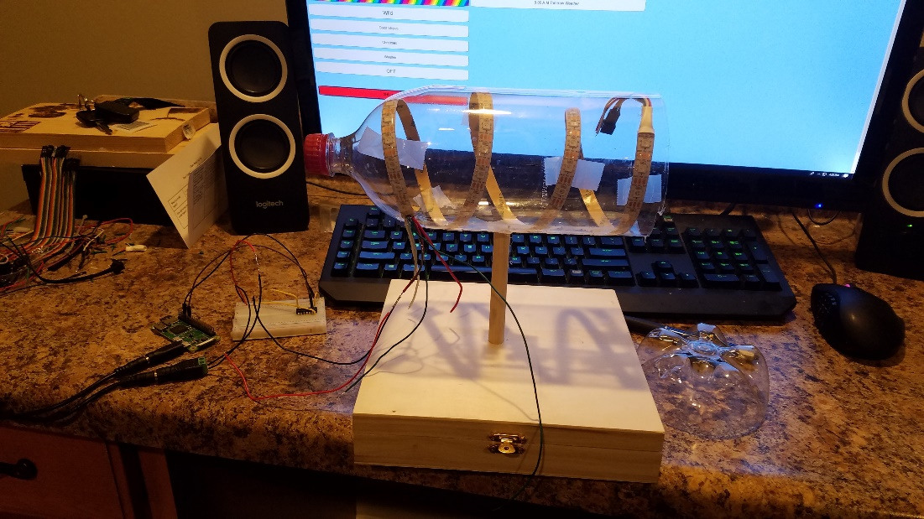Figure 3a.

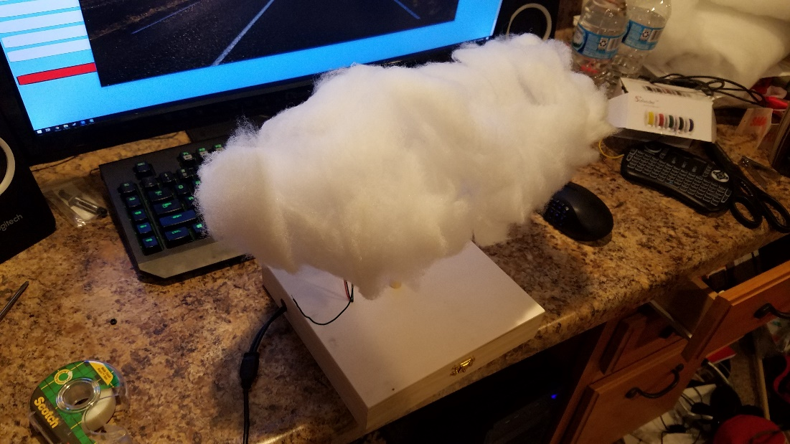Figure 3b.

1. On your wooden box, drill a hole through on of the sides. It does not matter which, so choose the side that will best fit your needs. This is the hole the power cord will go through.
2. Now, place the Raspberry Pi and breadboard inside the box. Pull the power supply cord through the hole. You may need to unhook and then reinsert wires throughout this process
3. Use hot glue to stick the Raspberry Pi and breadboard to the box. Hot glue is non-conductive and is therefore safe to use with electrical components.
4. Drill a hole in the top of the box above where the breadboard is. Make sure the LED strip is outside of the box and put the wires through that hole and into the correct places in the breadboard.
5. Cut your dowel to an appropriate size, and hot glue it to the top of the wood box.
6. Take off any wrapping around the liter bottle and cut it open on the end as shown in Figure 3a. Keep the end that is cut off, as you will need to tape it back on afterwards
7. Cut a small hole towards the cap as to allow the LED strip wires through
8. Hot glue the bottle to the top of the dowel
9. Wrap the LED strip around the inside of the bottle and ensure that the side with the wire inputs is toward the small open hole.
10. Reconnect the LED strip wires through the small hole in the top of the box to the LED strip. Use the pictures above as references.
11. Now, the Raspberry Pi and breadboard should be inside the box, and the LED strip should be inside the bottle. Everything should be connected correctly. Tape the end of the liter bottle back on.
12. Take the polyfiber filling and rip of small pieces of it. Hot glue them around the bottle.

You now should have the finished product. It will look something like Figure 3b. Now it is time to power on the Raspberry Pi and start running the script.

5) Finishing Touches

1. Plug in the Raspberry Pi
2. SSH into the Raspberry Pi using the same steps as in part 1.
3. Enter into the command line sudo python3 weatherScript.py

After a few seconds, the lights on the LED should turn bright green. Your Raspberry Pi Weather Cloud has been setup. Using the control panel, there are a multitude of different colors you can change the lights to. The weather cloud’s features and how to use them are explained in the Control Panel Section.

Implementation of SQLite

The weather cloud uses a script that runs 24/7 to gather the weather data from Openweather.org and stores the data into the database. The LED lights are then programmed to light up accordingly with the weather data from the site.

WIRING SETUP

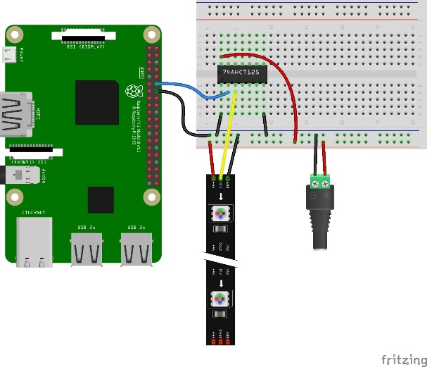 Figure3c.

* **Pi GPIO18** to **74AHCT125 pin 1A**
* **74AHCT125 pin 1Y** to **NeoPixel DIN**
* **Power supply ground**to **74AHCT125 ground**
* **Power supply ground** to **74AHCT125 pin 1OE**
* **Power supply ground** to **Pi GND**
* **Power supply ground**to **NeoPixel GND**
* **Power supply 5V** to **74AHCT125 VCC**
* **Power supply 5V** to **NeoPixel 5V**.

CONTROL PANEL

This section will cover usage of the control panel for the Raspberry Pi Weather Cloud.

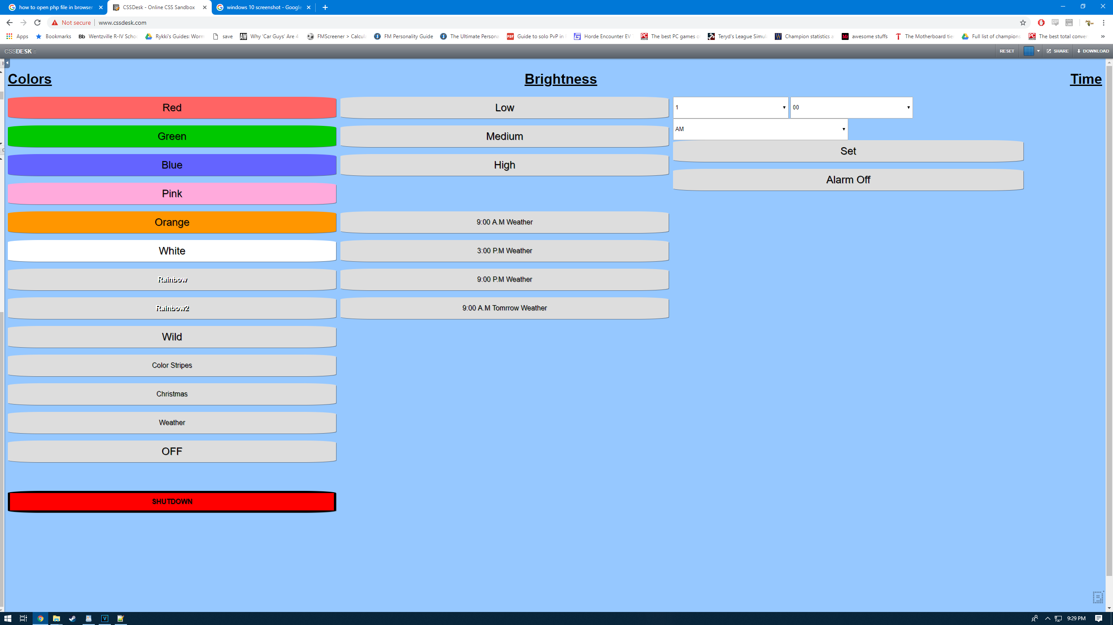

**Colors**

* Red, Green, Blue, Pink, Orange, and White all change the lights to their respective colors
* Rainbow, Rainbow2 – These make the lights rotate through the colors of the rainbow in different ways
* Wild – Bright flashes of different colors
* Color Stripes – Cycles through different colors in waves
* Christmas – Flashes Christmas Colors
* Weather – This is the most complex mode for the weather cloud. This mode changes the colors based on the weather forecast for the day.
  + The left side of the cloud will display a color for the current weather condition outside, such as rain, snow, sleet, cloudy, or sunny.
  + The right side of the cloud will only display either red or blue. Red will display if it is currently hotter than the day before, while blue will display if it is currently colder.



Examples of the weather cloud working (Figure 4a & 4b)

**Brightness**

* Low, Medium, and High will change the brightness level of the lights
* The weather times will change the time of day that the weather cloud will display for weather mode

**Time**

* It is possible to set a time for the weather cloud to automatically turn on and enter weather mode.
  + Simply select an hour on the left dropdown and minutes on the right, then press Set
* “Alarm Off” will disable the cloud from automatically turning on

Standard Operating Procedure

Effective Date: 3/16/19

**STANDARD OPERATING PROCEDURE**

**SAFELY WORKING WITH WIRING FOR RASPBERRY PI WEATHER CLOUD**

Hazard Assessment and Standard Operating Procedure (SOP) for working with Low Voltage

The best-known method for preventing electrical hazards and injuries is to pre plan activities and use appropriate procedures and materials specified within the instruction manual.

|  |  |  |
| --- | --- | --- |
| Areas to Asses | Physical Hazards Identified | How are Hazards Controlled |
| Work area should be clear of flammable items | Anything Flammable |  |
| Safeguards in place, Personal Protective Equipment if Needed |  |  |
| Loose clothing Eliminated |  |  |
| Static electricity is discharged |  | Anti-static wristguard |
|  |  |  |

Troubleshooting

While following these instructions there could be multiple reasons why you raspberry pi isn’t working correctly. Before you give up on your weather cloud, make sure you check some common problems that could occur.

1) Check and make sure that the power supply you are using is connected properly and is an actual 5v supply.

2) Make sure you are using the latest version of Raspbian or the operating system that you choose. Some raspberry pi’s won’t work with an out of date SD card image.

3) Make sure you power down your raspberry pi correctly. This can lead to a corrupted SD card.

4)Ensure that all the tables made in the SQLite database are named correctly



APPENDIX A

SAFETY INSTRUCTIONS FOR RASPBERRY PI WEATHER CLOUD USERS

It is important to understand these safety instructions when using this instrument. You must be very cautious and work safely. Safety rules control the risk of injury from hazards.

This appendix contains information pertaining to safe use of the Raspberry Pi Weather Cloud.

Make a photocopy of these instructions and place near the working space.

* 1. Flames and smoke are not allowed in the working area.
  2. Ensure that hands are dry and wear protective clothing before use.
  3. Disconnect the power source before servicing or repairing electrical equipment.
  4. Do not plug unnecessary items into the power strip.
  5. Do not pull any electrical cords from the wall.
  6. Ensure all electrical cords are out of the walkway.
  7. Keep all electrical items away from water.



APPENDIX B

PARTS REPLACEMENT LIST

This document describes the parts that can be replaced and retailers where items are sold.

Review this document before using the Raspberry Pi Weather Cloud and refer to it as needed.

|  |  |  |
| --- | --- | --- |
| ITEM | PART NUMBER | WHERE TO PURCHASE |
| Polyfiber Filling | PF16B | Amazon |
| Jumper Wires | 3-02-0997 | Amazon |
| Breadboard | Mmo-PN-329602646 | Amazon |
| Dowel | 6316U | Amazon |
| Wooden box 8x8x2 | B07JMZK2KX | Amazon |
| Empty Soda Bottle | BOT-600 | Teachersouce.com |
| WS2812 LED strip | WS2812B5M60LB30 | Amazon |



APPENDIX C

EXPLANATION OF TERMS

Listed in alphabetical order

**MicroSD card**: a type of removable [flash memory](https://simple.wikipedia.org/wiki/Flash_memory) card used for storing information. SD is an abbreviation of [Secure Digital](https://simple.wikipedia.org/wiki/Secure_Digital_card).

**Operating System**: the software that supports a computer's basic functions, such as scheduling tasks, executing applications, and controlling peripherals.

**Power Strip:** an electrical device consisting of a cord with a plug on one end and several outlets on the other

**Power Supply**: is a hardware component that supplies power to an electrical device. It receives power from an electrical outlet and converts the current from AC (alternating current) to DC (direct current), which is what the computer requires.

**Raspberry Pi**: is a small sized computer that plugs into a computer monitor or TV. It uses a standard keyboard and mouse.

**Web Server**: a program that uses HTTP (Hypertext Transfer Protocol) to serve the files that form Web pages to users, in response to their requests, which are forwarded by their computers' HTTP clients.

Sources

<https://www.raspberrypi.org/documentation/remote-access/web-server/apache.md> (apache and php install)

<https://www.raspberrypi-spy.co.uk/2012/06/simple-guide-to-the-rpi-gpio-header-and-pins/> (wiring gpio diagram)

<https://learn.adafruit.com/neopixels-on-raspberry-pi/raspberry-pi-wiring> (wiring diagram)

<https://rasspberrypi.wordpress.com/2012/09/03/enabling-ssh-on-raspberry-pi-and-using-putty-and-winscp/> (WinSCP image)

<http://www.rawinfopages.com/apps/index.php/android/356-5-android-wi-fi-analysers-to-detect-intruders-on-your-network> (Fing image)

<https://leanpub.com/jerpi/read> (rasp pi sd slot image)

<https://kb.sandisk.com/app/answers/detail/a_id/14827/~/using-sd-formatter-tool-to-restore-full-capacity-on-sdhc%2Fsdxc-cards> (sd card formatter program image)

<https://learn.adafruit.com/neopixels-on-raspberry-pi/raspberry-pi-wiring> (raspberry pi wiring)

<https://www.raspberrypi.org/learning/troubleshooting-guide/> (troubleshooting)